DOMOTICZ Home Automation Guide

Ver 1

El Zorro Vega

27 April 2023

**DISCLAIMER**

Please read this disclaimer carefully before using this guide. The content displayed on the website was intended merely for educational and informational purposes. It is not intended as a substitute for professional advice. Should you decide to act upon any information on this website, you do so at your own risk.

While the information on this website has been verified to the best of our abilities, we cannot guarantee that there are no mistakes or errors. We reserve the right to change this policy at any given time, of which you will be promptly updated. If you want to make sure that you are up to date with the latest changes, we advise you to frequently visit this page.

Table of Contents

# [Introduction 3](#__RefHeading___Toc3944_1653942091)

# [Platform Choice 4](#__RefHeading___Toc3439_2683865589)

## [RPI Domoticz Server 4](#__RefHeading___Toc3967_2683865589)

## [RPI2 Sandbox 4](#__RefHeading___Toc3969_2683865589)

# [LINUX 8](#__RefHeading___Toc3441_2683865589)

# [Image Burning 11](#__RefHeading___Toc3443_2683865589)

# [USB Booting 13](#__RefHeading___Toc3445_2683865589)

## [Raspberry Pi 4B 13](#__RefHeading___Toc3578_1653942091)

## [Raspberry Pi 3B+ 14](#__RefHeading___Toc3580_1653942091)

# [Docker Installation 15](#__RefHeading___Toc3447_2683865589)

## [Install Docker 15](#__RefHeading___Toc3582_1653942091)

# [MQTT Installation 17](#__RefHeading___Toc3449_2683865589)

## [Wiki Documentation Links 19](#__RefHeading___Toc3588_1653942091)

## [Domoticz Configuration 19](#__RefHeading___Toc3590_1653942091)

## [Install Mosquitto 19](#__RefHeading___Toc3592_1653942091)

## [Install Zwave-JS 19](#__RefHeading___Toc3594_1653942091)

## [Install Zwave-JS-UI 19](#__RefHeading___Toc3596_1653942091)

## [Zwave-JS-UI/Domoticz Configuration 21](#__RefHeading___Toc3598_1653942091)

## [Domoticz MQTT Gateways 23](#__RefHeading___Toc3600_1653942091)

## [New Devices from Zwave-JS-UI 24](#__RefHeading___Toc3602_1653942091)

## [Zwave-JS-UI Control Panel Page 1 25](#__RefHeading___Toc3604_1653942091)

## [Zwave-JS-UI Control Panel Page 2 25](#__RefHeading___Toc3606_1653942091)

## [Zwave-JS-UI Provisioning Entities 26](#__RefHeading___Toc3608_1653942091)

## [Zwave-JS-UI Settings 27](#__RefHeading___Toc3610_1653942091)

## [Zwave-JS-UI Debug 31](#__RefHeading___Toc3612_1653942091)

## [Zwave-JS-UI Store 31](#__RefHeading___Toc3614_1653942091)

## [Zwave-JS-UI Network 32](#__RefHeading___Toc3616_1653942091)

## [Zwave-JS-UI Debug Errors with localhost IP 33](#__RefHeading___Toc3618_1653942091)

# [Remote Access 34](#__RefHeading___Toc3456_2683865589)

## [VNC 34](#__RefHeading___Toc3620_1653942091)

## [DuckDNS 34](#__RefHeading___Toc3622_1653942091)

# [NAT Router set-up 36](#__RefHeading___Toc3624_1653942091)

# [Certificate with snapd & certbot 36](#__RefHeading___Toc3626_1653942091)

# [Scripts 37](#__RefHeading___Toc3458_2683865589)

## [mdown.sh 37](#__RefHeading___Toc3628_1653942091)

## [updom.sh 37](#__RefHeading___Toc3630_1653942091)

## [rpidia.sh 38](#__RefHeading___Toc3632_1653942091)

## [inadyn.sh 38](#__RefHeading___Toc3634_1653942091)

## [smeagol.sh 38](#__RefHeading___Toc3636_1653942091)

# [Glossary 39](#__RefHeading___Toc3460_2683865589)

# Introduction

"Practise makes perfect!" However, when you do not practise often you face, "the devil is in the details." Thus, I thought it would be good to jot down the Domoticz experience to help refresh one’s memory and share the experience with others. Once again this is just a humble attempt to document somewhat chaotic approach to a particular method to problem solving method. You are free to modify and share it with others.

Our internet provider offered a basic security system service which included Z-Wave nodes. The service was discontinued some two years later which left me with the option to throw away or reuse. Via Internet, I found about Domoticz Home Automation. It’s an open source multi-platform project which could run on a Raspberry Pi (RPI). Some colleagues at work gave positive feedback about the hardware and I decided to take the plunge. In the worst case scenario, we would acquire another computer at home for less than € 50. Little to lose but much to gain if this combination was the answer to recover the Z-wave devices from our old security system.

Although, we had Linux machines at home the RPI experience was refreshing. It’s computing power is as much if not more that what we have in our current smartphones and tablets. The catch is that the user is also the system administrator. Thanks to Internet, this makes the job easier but it’s time consuming! My recommendation is to update RPI OS very often unless there are some counter indications in the Domoticz literature. Let’s keep in mind that it is the backbone running all applications. Thus, the need for these notes.

Domoticz is in our home since 2019 and it here to stay.

**Thanks to the people who make it work!**

# Platform Choice

RPI has various advantages to run Domoticz. It’s price, power consumption and maintenance feasibility are on the top of the list. My recommendation is to get two RPIs along with at least two SD cards and a few USB memory sticks of at least 64 GB and one of 256GB. You will also need an SD to USB Adapter which will allow to read your SD disc and make your images.

Personally, I had some difficulty booting from Kinston Data Traveller USB flash drives and internet post suggest to avoid Verbatim. ScanDisk drives seem to be more RPI user friendly. I recommend new USB 3.0 flash drives to take advantage of the speed specially with RPI4.

One RPI runs Domoticz while the other is my sandbox/backup machine where experiments take place. My configuration is as follow:

## RPI Domoticz Server

*DOMOTICZ Information*

*build\_time : 2023-02-14 15:06:40*

*dzvents\_version : 3.1.8*

*hash : f9b9ac774*

*python\_version : 3.9.2 (default Feb 28 2021 17:03:44) \n[GCC 10.2.1 20210110]*

*version : 2023.1*

*RASPBERRY Pi Information*

*Linux version 6.1.21-v8+ (dom@buildbot) (aarch64-linux-gnu-gcc-8 (Ubuntu/Linaro 8.4.0-3ubuntu1) 8.4.0, GNU ld (GNU Binutils for Ubuntu) 2.34) #1642 SMP PREEMPT Mon Apr 3 17:24:16 BST 2023*

*Hardware : BCM2835*

*Revision : a020d3*

*Serial : 00000000cc7e2232*

*Model :* ***Raspberry Pi 3 Model B Plus Rev 1.3, 1 GB SDRAM***

*H264: H264=enabled*

*MPG2: MPG2=disabled*

*WVC1: WVC1=disabled*

*MPG4: MPG4=enabled*

*MJPG: MJPG=enabled*

*WMV9: WMV9=disabled*

## RPI2 Sandbox

*RASPBERRY Pi Information*

*Linux version 6.1.21-v8+ (dom@buildbot) (aarch64-linux-gnu-gcc-8 (Ubuntu/Linaro 8.4.0-3ubuntu1) 8.4.0, GNU ld (GNU Binutils for Ubuntu) 2.34) #1642 SMP PREEMPT Mon Apr 3 17:24:16 BST 2023*

*Hardware : BCM2835*

*Revision : d03114*

*Serial : 100000000bf31ede*

*Model :* ***Raspberry Pi 4 Model B Rev 1.4, 8 GB SDRAM***

*H264: H264=enabled*

*MPG2: MPG2=disabled*

*WVC1: WVC1=disabled*

*MPG4: MPG4=disabled*

*MJPG: MJPG=enabled*

*WMV9: WMV9=disabled*

Link below is to the official Raspberry Pi Guide. It contains amongst, other thing, instructions to install Debian ARM ( Linux distribution for RPI processor) operating system.

<https://www.raspberrypi.com/documentation/computers/raspberry-pi.html>

You also should pay close attention to web page <https://www.domoticz.com/wiki/Raspberry_Pi> for here there are good recommendations as to RPI’s setup.

Bottom line is that you need to install the Operating System (OS) from another PC to your SD card. Once image is "burnt" then start-up from SD Card and configure your RPI to your hearts content. I recommend to burn a second SD which will be used later. Here is a sample of the applications installed on my host machine (Pi 3 Model B Plus) along with Domoticz.

*gedit*

*korganizer*

*firefox*

*claws -mail client*

*audacity*

*gparted*

*dosfstools*

*mtools*

*gimp*

*sqlite3*

*gucharmap*

*realvnc vnc-viewer*

*LibreOffice*

*ttf-mscorefonts-installer-3.8*

*SimpleScreenRecorder*

*mosquitto install*

*sudo apt install -y mosquitto mosquitto-clients*

*sudo systemctl enable mosquitto.service*

*mosquitto -v*

*sudo gedit /etc/mosquitto/mosquitto.conf*

*Docker Install*

*https://linuxize.com/post/how-to-install-and-use-docker-on-raspberry-pi/*

*curl -fsSL https://get.docker.com -o get-docker.sh*

*sh get-docker.sh*

*Chromium 32-bit downgrade*

*sudo apt install chromium-browser:armhf libwidevinecdm0*

*#download script to link chromium and widevine#*

*curl -fsSL https://pi.vpetkov.net -o ventz-media-pi*

*sh ventz-media-pi*

*Smeagol MQTT Explorer NodeJS HTTP Server*

*cd store*

*sudo docker pull smeagolworms4/mqtt-explorer*

*sudo docker run -p 4000:4000 -v$(pwd)/config:/mqtt-explorer/config smeagolworms4/mqtt-explorer*

Ensure that both SSH and VNC interfaces are available to access host machine remotely.

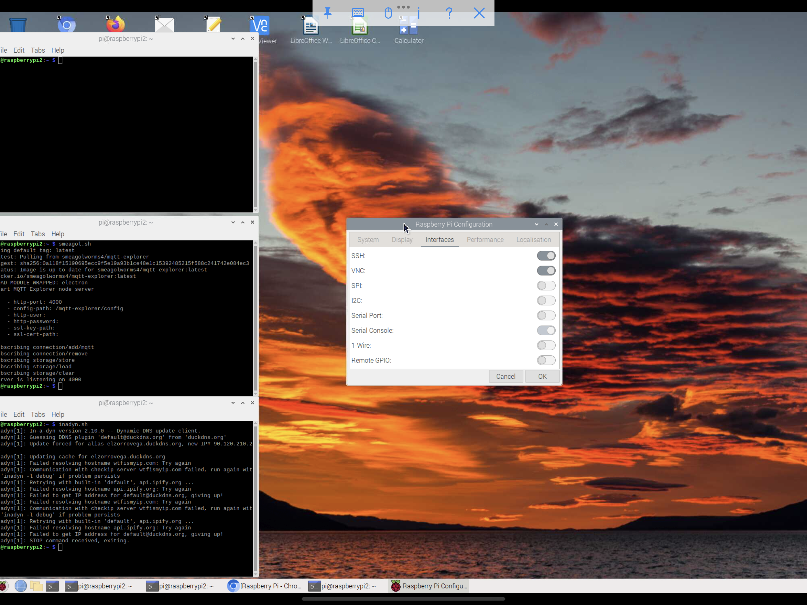

A DzVents script runs on Domoticz host machine to collect system information such as system used RAM memory. Previous versions of Domoticz which supported Open Z-wave and my basic system applications used approximately 50 % total RAM. Current base services have used RAM memory around 60 %. If you CLI ps -auxf, you will see all process currently running. Some of these are on standby but some of them are using system resources. Thus, you need to streamline your applications ( docker, mosquitto, etc ) running in parallel to Domoticz. Be aware that web browsers are system resource hogs! Every time you open a tab, they normally open another browser session. Once Domoticz server is running in host machine, you can always use a client session from a remote machine within Local Area Network (LAN) to interact with Domoticz. A VNC connection is also a simple way of interacting with the Domoticz host machine remotely even from the internet.

The second RPI(Pi 4 Model B) is the "sandbox" or playground machine. This is where one can tests OS updates amongst other things. Although Bullseye-64 has an applet for upgrades, I recommend to use CLIs such as:

$ sudo apt update

$ sudo apt dist-upgrade -y

For this terminal command will upgrades your OS but you will see which applications will be concerned and are they used by Domoticz. If docker, mosquitto are concerned, it probably a good idea to see in the forums if someone else did not have issues with these upgrades. The ultimate test will be to reset you host machine after upgrades and see if Domoticz starts-up normally. Continue to customise your system to fit your needs. You will notice that between installation, upgrades and customisation you have spent a few hours. I strongly recommend to keep a diary of your changes to ensure that you do not forget things for the next time you do the same exercise.

The next important step after documenting the changes will be making an OS system image to save all the work from before. I suggest to have one flash drive of at least 128 Gb to allow you to save your compressed system images. Although a memory stick says that it’s 64 GB, it will be less for example 58.7 GB. Manufacturer reserve a certain space for formatting. It would be sheer luck to have an USB flash drive bigger than your SD card.

Another recommendation is to invest an UPS (Uninterruptible Power Supply). Connected to this should be your RPI as well as internet provider router. Some UPS come with monitoring software to trigger shutdown sequence in their host machines. If there are risks of micro power failures in your area, RPI would be much obliged to avoid brutal shutdowns which can corrupt certain system files and Domoticz own SQLite data base.

# LINUX

"Change is inevitable." Thus, if we try to anticipate it we can be better prepared to face it. Linux desktop is roughly around 2.9 % compared to 69 % for Windows based systems but then again our goal here is to prepare a Domoticz server and Linux represents a 40 % share. Again, these are just numbers but the more we know about the "animal" the easier will be to tame it.

Linux comes in different distributions which are better suited for certain uses. We shall work Debian ARM ( Linux distribution for RPI processor) operating system. With it you can use Open Office for say spreadsheets, word processing and presentations and depending on your specific needs there probably is an open source application which can do what you would like or almost. If not then, you can dabble in code and make your own "stuff".

Although Linux has a built in reference guide say man dd, which will display additional information about options and arguments concerning this particular command, I recommend to invest in a **Linux** **Reference Guide** which can always be consulted specifically when Internet is not available. De facto, you just became **System Administrator**; thus, an OS overview will probably go a long way to help solving system issues.

Linux is both multitask/multiuser system and during installation, user name and password will be requested. Directory */home/pi* will be created by default where all user related data will be stored. Linux files also have attributes such as owner, group and read/write/execute permissions. Linux is also case sensitive so that CLI cd will be recognised while CD will give an error message.

**Lxpanel** a graphic (GUI) desktop application, **lxterminal** a terminal emulator and Bash shell a command interpreter are default features with RPI. Although a lot of tasks can be done via the GUI, you will encounter situation when a simple CLI will do what you need. Thus, I encourage you to play in the sandbox with the myriad of commands which are at your finger tips in the terminal. When you combine these within scripts you will simplify your administrator tasks. Take for example the USB flash disc formatted to ext4 to which I gave the label Scandisk114G. When insert, it’s mounted under /media/pi/Scandisk114G. After formatting, I needed to change the owner of the disc to ensure that read/writing tasks to the disc did not require super user rights (sudo) every time.

$ cd /media/pi/Scandisk114G

$ chown -R pi /media/pi/Scandisk114G

$ ls -la

total 4188688

drwxr-xr-x 3 pi pi 4096 Apr 15 18:05 .

drwxr-x---+ 3 root root 4096 Apr 23 12:17 ..

drwx------ 2 pi pi 16384 Apr 15 16:00 lost+found

-rw-r--r-- 1 pi pi 4289186552 Apr 15 17:41 myimg.img.gz

Shell Scripts are like macros under EXCEL and these can be even be made interactive. All my scripts are in under */home/pi/Scripts* directory and in */etc/profile* file added */home/pi/Scripts* to PATH environment variable. User scripts are now accessible anywhere in the system.

$ cat /etc/profile

# /etc/profile: system-wide .profile file for the Bourne shell (sh(1))

# and Bourne compatible shells (bash(1), ksh(1), ash(1), ...).

if [ "$(id -u)" -eq 0 ]; then

PATH="/usr/local/sbin:/usr/local/bin:/usr/sbin:/usr/bin:/sbin:/bin"

else

PATH="/usr/local/sbin:/usr/local/bin:/usr/sbin:/usr/bin:/sbin:/bin:/home/pi/Scripts:/usr/local/games:/usr/games"

fi

export PATH

..

$ cd

pi@raspberrypi2:~ $ pwd

/home/pi

pi@raspberrypi2:~ $ ls -l

total 60

drwxr-xr-x 2 pi pi 4096 Apr 7 23:05 Bookshelf

drwxr-xr-x 2 pi pi 4096 Apr 7 23:05 Desktop

drwxr-xr-x 5 pi pi 4096 Apr 16 19:29 Documents

drwxr-xr-x 2 pi pi 4096 Apr 7 23:05 domoticz

drwxr-xr-x 2 pi pi 4096 Apr 13 18:48 Downloads

drwxr-xr-x 2 pi pi 4096 Apr 7 23:05 Music

drwxr-xr-x 2 pi pi 4096 Apr 7 23:05 Pictures

drwxr-xr-x 2 pi pi 4096 Apr 7 23:05 Public

drwxr-xr-x 2 pi pi 4096 Apr 14 22:07 Scripts

drwxr-xr-x 2 pi pi 4096 Apr 7 23:05 Sound

drwxr-xr-x 5 pi pi 4096 Apr 7 23:05 store

drwxr-xr-x 2 pi pi 4096 Apr 7 23:05 Templates

drwxr-xr-x 2 pi pi 4096 Apr 7 23:05 Videos

In conclusion, you will need to poke your nose in Linux to ensure that host machine running Domoticz and it’s affiliated applications are up to date and stable. By leaving the system static you will probably miss out on the latest and greatest features.

# IMG_0163.pngImage Burning

Once you finish customising your RPI, take the second SD card and put it in your SD/USB adapter. If not done, use Raspberry Pi Imager to install RPI OS to second SD card. Use $ gparted to format your largest USB flash drive with ext4. It’s will be used to store raw images and backup your files.

Power down your RPI and switch SD cards. On other words, your customised SD card is now in your adapter. You will need to configure your second SD card and update it. There will be no need to customise it for you just needed for basic RPI functions.

I recommend to visit the the site below which has more details.

<https://www.tomshardware.com/how-to/back-up-raspberry-pi-as-disk-image>

RPI OS includes two partitions boot and root which should look something like this:

pi@raspberrypi:~ $ lsblk

NAME MAJ:MIN RM SIZE RO TYPE MOUNTPOINT

sda 8:0 1 57.3G 0 disk

|-sda1 8:1 1 256M 0 part /boot

`-sda2 8:2 1 57G 0 part /

Below is a screen copy of the tools used for image burning.

Image Compression Tool

wget <https://raw.githubusercontent.com/Drewsif/PiShrink/master/pishrink.sh>

$ sudo chmod +x pishrink.sh

$ sudo mv pishrink.sh /usr/local/bin

Use CLI dd (Dataset Definition) command to copy an image of the entire SD card to a flash drive of say 128 GB which is installed in other free USB port. This operation’s time limiting factor will be either the reading or writing speed. Regardless, let your RPI do its job. A file the size of your SD card will now be written to your USB flash drive. Assuming you SD card is 64 GB, dd will makes a copy to USB flash drive as long as it has enough free space. Then, run pishrink script to create a compressed image file which can then be loaded onto an SD card or USB Memory Stick with PI Imager. Compressed image should be somewhere are 3 or 4 GB. Once image decompressed to new flash drive, it turned out to be somewhere around 9 GB. You will probably need to reallocated unused usb flash disc memory to your ext4 partition with gparted disc utility.

To clone an entire disk, say for example sdd to external mounted disk (label Raspdrive), run:

$ sudo mount /dev/sdc /media/pi

$ sudo dd if=/dev/sdd of=/media/pi/Raspdrive/myimg.img bs=1M

$ cd /media/pi/Raspdrive

$ sudo pishrink.sh -z myimg.img

If an update or a command leaves your system inoperable, then you can always burn the last system backed-up image to your disc and return to a comfortable starting point. Remember all the hours you spent tailoring your RPI, it would be a shame to begin the work from original starting point!

# USB Booting

Literature recommends to use flash drives as opposed to SD cards because the latter are more likely to fail if there are constant read/write tasks. Thus, the need to use USB flash drive booting.

As mentioned previous, you may find difficulties making a bootable RPI OS with Verbatim and some Kingston flash drives. I tried different images but result was always poor booting. To show all RPI booting messages do the following:

Save original

sudo cp /boot/cmdline.txt /boot/cmdlinebak.txt

Edit */boot/cmdline.txt* file, and remove the quiet directive

According to boot messages Kingston flash drives could not initialise Bluetooth services and RPI took five minutes to boot without any Bluetooth devices operational. System response time was slow to the point of being useless. The issue could have been image itself, imager copy software, usb flash drive or a combination of the above.

ScanDisk flash drives worked much better for me.

## Raspberry Pi 4B

Show actual boot loader

$ vcgencmd bootloader\_config

Edit the configuration to change boot order so that both SD & USB are bootable. BOOT\_ORDER should be set to 41.

$ sudo -E rpi-eeprom-config --edit

[ all]

BOOT\_UART=0

WAKE\_ON\_GPIO=1

POWER\_OFF\_ON\_HALT=0

DHCP\_TIMEOUT=45000

DHCP\_REQ\_TIMEOUT=4000

TFTP\_FILE\_TIMEOUT=30000

TFTP\_IP=

TFTP\_PREFIX=0

BOOT\_ORDER=**0xf41** Try SD first, followed by USB-MSD then repeat (default if BOOT\_ORDER is empty)

SD\_BOOT\_MAX\_RETRIES=3

NET\_BOOT\_MAX\_RETRIES=5

[none]

FREEZE\_VERSION=0

**Remember that USB boot is only possible from USB 2.0**.

## Raspberry Pi 3B+

According to RPI literature, this model supports USB boot by default check the following site [https://www.raspberrypi.com/documentation/computers/raspberry-pi.html#raspberry-pi-3b](https://www.raspberrypi.com/documentation/computers/raspberry-pi.html" \l "raspberry-pi-3b).

The following command should show the following:

vcgencmd otp\_dump | grep 17:

17:3020000a

If this is not the case, then follow the following steps are needed to set the OTP bit.

echo program\_usb\_boot\_mode=1 | sudo tee -a /boot/config.txt

Burnt an image to USB flash drive and booted on first on RPI 4B and then on RPI 3b+.

**Remember that USB boot is only possible from USB 2.0.**

# Docker Installation

Docker allows to to run applications, libraries, system tools, etc in a separate environment in parallel to your system. Note that MQTT (Message Queuing Telemetry Tool) Zwave-JS-UI runs in a docker container.

### Install Docker

<https://www.simplilearn.com/tutorials/docker-tutorial/raspberry-pi-docker>

Get installation script:

curl -fsSL https://get.docker.com -o get-docker.sh

# Executing docker install script, commit: 4f282167c425347a931ccfd95cc91fab041d414f

+ sudo -E sh -c apt-get update -qq >/dev/null

+ sudo -E sh -c DEBIAN\_FRONTEND=noninteractive apt-get install -y -qq apt-transport-https ca-certificates curl >/dev/null

+ sudo -E sh -c mkdir -p /etc/apt/keyrings && chmod -R 0755 /etc/apt/keyrings

+ sudo -E sh -c curl -fsSL "https://download.docker.com/linux/debian/gpg" | gpg --dearmor --yes -o /etc/apt/keyrings/docker.gpg

gpg: WARNING: unsafe ownership on homedir '/home/pi/.gnupg'

+ sudo -E sh -c chmod a+r /etc/apt/keyrings/docker.gpg

+ sudo -E sh -c echo "deb [arch=arm64 signed-by=/etc/apt/keyrings/docker.gpg] https://download.docker.com/linux/debian bullseye stable" > /etc/apt/sources.list.d/docker.list

+ sudo -E sh -c apt-get update -qq >/dev/null

+ sudo -E sh -c DEBIAN\_FRONTEND=noninteractive apt-get install -y -qq --no-install-recommends docker-ce docker-ce-cli containerd.io docker-compose-plugin >/dev/null

+ version\_gte 20.10

+ [ -z ]

+ return 0

+ sudo -E sh -c DEBIAN\_FRONTEND=noninteractive apt-get install -y -qq docker-ce-rootless-extras >/dev/null

+ sudo -E sh -c docker version

Client: Docker Engine - Community

Version: 20.10.22

API version: 1.41

Go version: go1.18.9

Git commit: 3a2c30b

Built: Thu Dec 15 22:27:20 2022

OS/Arch: linux/arm64

Context: default

Experimental: true

Server: Docker Engine - Community

Engine:

Version: 20.10.22

API version: 1.41 (minimum version 1.12)

Go version: go1.18.9

Git commit: 42c8b31

Built: Thu Dec 15 22:25:43 2022

OS/Arch: linux/arm64

Experimental: false

containerd:

Version: 1.6.14

GitCommit: 9ba4b250366a5ddde94bb7c9d1def331423aa323

runc:

Version: 1.1.4

GitCommit: v1.1.4-0-g5fd4c4d

docker-init:

Version: 0.19.0

GitCommit: de40ad0

================================================================================

To run Docker as a non-privileged user, consider setting up the

Docker daemon in rootless mode for your user:

dockerd-rootless-setuptool.sh install

**Run script**

sudo sh get-docker.sh

If Docker is installed and running, ps command output looks like this

$ pstruc.sh | grep erd

root 668 0.1 5.5 1354332 50072 ? Ssl 17:19 0:04 /usr/bin/dockerd

root 521 0.0 3.4 1335144 31576 ? Ssl 17:19 0:02 /usr/bin/containerd

# MQTT Installation

Open Zwave’s is at the end of life cycle and will eventually be deprecated. Domoticz newer releases such version 2022.1 use MQTT gateways, MQTT Broker like Mosquitto and an application such as Zwave-JS-UI to communicate to field devices. Forum pages and comments were very helpful. After some blood, sweat, tears and some luck, managed to communicate via Zwave-JS-UI to my old devices.

As per numerous recommendation backup current Domoticz directory just in case. Furthermore, ***document current Open Zwave hardware configuration*** ***Setup> Hardware*** for it will come on useful to name your nodes if MQTT Auto Discovery does not do it as was my case.

018 (0x12) Smoke Detector 1 FGSD002 Smoke Sensor+ FIBARO System 0x1003 0x0c02 2023-02-12 11:47:01

017 (0x11) Fibaro Wall Plug Living FGWPE/F Wall Plug Gen5+ FIBARO System 0x1003 0x0602 2023-02-12 11:53:56

016 (0x10) Fibaro Wall Plug 3 FGWPE/F Wall Plug Gen5+ FIBARO System 0x1003 0x0602 2023-02-12 11:54:09

015 (0x0f) Fibaro Wall Plug 2 FGWPE/F Wall Plug Gen5+ FIBARO System 0x1003 0x0602 2023-02-12 11:54:03

014 (0x0e) Kitchen D/W FGDW002 Door Opening Sensor 2+ FIBARO System 0x1000 0x0702 2023-02-12 11:47:01

013 (0x0d) Chamber 2 Motion Sensor FGMS001-ZW5 Motion Sensor+ FIBARO System 0x1002 0x0801 2023-02-12 11:47:01

012 (0x0c) Chamber 1 Motion Sensor FGMS001-ZW5 Motion Sensor+ FIBARO System 0x1002 0x0801 2023-02-12 11:55:04

011 (0x0b) Chamber 2 D/W FGK101 Door Opening Sensor FIBARO System 0x1000 0x0700 2023-02-12 11:55:18

010 (0x0a) Chamber 3 D/W FGK101 Door Opening Sensor FIBARO System 0x1000 0x0700 2023-02-12 11:51:07

009 (0x09) Bathroom D/W FGK101 Door Opening Sensor FIBARO System 0x1000 0x0700 2023-02-12 11:55:07

008 (0x08) Hall Siren ZW080 Siren Gen5+ AEON Labs 0x0050 0x0004 2023-02-12 11:55:32

11007 (0x07) Hall Keyboard Mini Keypad RFID Schlage Link (Wintop) 0x4501 0x6131 2023-02-12 11:47:01

006 (0x06) Living Motion Sensor FGMS001 Motion Sensor FIBARO System 0x1001 0x0800 2023-02-12 11:47:01

005 (0x05) Hall Motion Sensor FGMS001 Motion Sensor FIBARO System 0x1001 0x0800 2023-02-12 11:54:18

004 (0x04) Chamber 1 D/W FGK101 Door Opening Sensor FIBARO System 0x1000 0x0700 2023-02-12 11:53:29

003 (0x03) Chamber 1 Siren ZW080 Siren Gen5+ AEON Labs 0x0050 0x0004 2023-02-12 11:55:43

002 (0x02) Fibaro Wall Plug 1 FGWPE/F Wall Plug FIBARO System 0x1000 0x0600 2023-02-12 11:54:00

001 (0x01) Controller ZW090 Z-Stick Gen5 EU AEON Labs 0x005a 0x0001 2023-02-12 11:47:01

Open Zwave Controlller Domoticz Aeotec Controller Set-up

Name: Controller

Configuration

1. Poll Interval: 60 (Seconds) (actual: 60)

Set the time period between polls of a node's state. The length of the interval is the same for all devices. To even out the Z-Wave network traffic generated by polling, OpenZWave divides the polling interval by the number of devices that have polling enabled, and polls each in turn. It is recommended that if possible, the interval should not be set shorter than the number of polled devices in seconds (so that the network does not have to cope with more than one poll per second).

2. Enable Debug: Disabled

Enable/Disable debug logging. It is not recommended to enable Debug for a live system as the log files generated will grow large quickly.

3. Enable Nightly Heal Network (04:00 am): Disabled

Enable/Disable nightly heal network.

4. Security Network Key: Security key S0 ***0102030405060708090A0B0C0D0E0F10***

0x01, 0x02, 0x03, 0x04, 0x05, 0x06, 0x07, 0x08, 0x09, 0x0A, 0x0B, 0x0C, 0x0D, 0x0E, 0x0F, 0x10

(actual: 0x01, 0x02, 0x03, 0x04, 0x05, 0x06, 0x07, 0x08, 0x09, 0x0A, 0x0B, 0x0C, 0x0D, 0x0E, 0x0F, 0x10)

If you are using any Security Devices, you MUST set a network Key The length should be 16 bytes!

5. RetryTimeout: 3000 (ms) (actual: 3000)

How long do we wait to timeout messages sent (default 10000)

6. Assume Awake: False

Assume Devices that Support the Wakeup CC are awake when we first query them.... (default True)

7. Perform Return Routes: True

if True, return routes will be updated

8. Enable Controller Blinking: Enabled

## Wiki Documentation Links

<https://www.domoticz.com/wiki/MQTT>

<https://www.domoticz.com/wiki/Zwave-JS-UI>

## Domoticz Configuration

Upgrade RPI OS

sudo apt-get update && sudo apt-get upgrade

Update Domoticz

Version: 2022.2

Build Hash: eea9db734

Compile Date: 2022-11-05 13:05:35

dzVents Version: 3.1.8

Python Version: 3.9.2 (default, Feb 28 2021, 17:03:44) [GCC 10.2.1 20210110]

Update Raspberry Pi 3 Model B+

Hardware : BCM2835

Revision : a020d3

Serial : 00000000cc7e2232

Model : Raspberry Pi 3 Model B Plus Rev 1.3

Linux raspberrypi 5.15.76-v8+ #1597 SMP PREEMPT Fri Nov 4 12:16:41 GMT 2022 aarch64 GNU/Linux - Bullseye -64 bit OS

Z-Wave Node

idVendor 0x0658 Sigma Designs, Inc.

idProduct 0x0200 Aeotec Z-Stick Gen5 (ZW090) - UZB

## Install Mosquitto

Mosquitto Broker is installed and configured as recommended for Raspbian environment in link below.

<https://randomnerdtutorials.com/how-to-install-mosquitto-broker-on-raspberry-pi/>

## Install Zwave-JS

I am new to Docker but to my understanding one runs an image of an application in local/cloud environment.

According to [https://zwave-js.github.io/zwave-js-ui/#/getting-started/docker?id=installation](https://zwave-js.github.io/zwave-js-ui/" \l "/getting-started/docker?id=installation)

## Install Zwave-JS-UI

There are three way to install Zwave-JS-UI image

1- Run using volumes

2- Run using local folder

3- Run as a service with

I understood, that in all cases we are to download a Zwave-JS-UI image. I chose the 2nd option and data is placed in */home/pi/store*directory. I was able to access Zwave-JS-UI image after running the following LCI

sudo docker run --rm -it -p 8091:8091 -p 3000:3000 -e TZ=Europe/Paris --device=/dev/serial/by-id/usb-0658\_0200-if00 \

-v $(pwd)/store:/usr/src/app/store zwavejs/zwave-js-ui:latest

Terminal shows activity and web interface allows configuration. However, after restarting the Raspberry Pi, the Zwave-JS-UI is not accessible.

I understood that file **docker-compose.yml** is needed to start-up Z-Wave JS UI as a container service, I decided to take the plunge. However, before enabling this service I took the following steps:

Saved configuration file in /home/pi/store/docker-compose.yml

docker-compose.yml

version: "3.7"

services:

zwave-js-ui:

container\_name: zwave-js-ui

image: zwavejs/zwave-js-ui:latest

restart: always

tty: true

stop\_signal: SIGINT

environment:

- SESSION\_SECRET=mysupersecretkey

#- SESSION\_SECRET=Para\_771#@

- ZWAVEJS\_EXTERNAL\_CONFIG=/usr/src/app/store/.config-db

# Uncomment if you want log times and dates to match your timezone instead of UTC

# Available at https://en.wikipedia.org/wiki/List\_of\_tz\_database\_time\_zones

- TZ=Europe/Paris

networks:

- zwave

devices:

# Do not use /dev/ttyUSBX serial devices, as those mappings can change over time.

# Instead, use the /dev/serial/by-id/X serial device for your Z-Wave stick.

- '/dev/serial/by-id/usb-0658\_0200-if00:/dev/zwave'

volumes:

- zwave-config:/usr/src/app/store

# Or by using local folder

# - ./store:/usr/src/app/store

ports:

- "8091:8091" # port for web interface

- "3000:3000" # port for Z-Wave JS websocket server

networks:

zwave:

volumes:

zwave-config:

name: zwave-config

Run command sudo docker-compose up -d

## Zwave-JS-UI/Domoticz Configuration

* Installed Mosquitto MQTT Auto Discovery Yes MQTT Auto Discovery Client Gateway with LAN interface localhost 1883 Disabled
* Installed Mosquitto MQTT Yes MQTT Client Gateway with LAN interface localhost 1883 Disabled
* Disabled Open Zwave gateway
* Auto Discovery is under way and ZWave hardware is updating in the zwave-js-ui database
* Old Zwave Devices are no longer in database
* Used following command to update dummy variable via MQTT to Domoticz database.
* mosquitto\_pub -h localhost -m '{ "idx" : 1730, "nvalue" : 0, "svalue" : "25.0" }' -t 'domoticz/in' writes value to dummy sensor. So MQTT is working.
* 24 hours after migration and numerous RPI resets, zwave-js-ui database is still not finished interviewing three of the devices ( 0x0d; 0x0e; 0x12). These were previously attached to Open Z-Wave without any unwanted issues. Furthermore, all the devices linked to the Open Z-Wave are still not created in the database. Zwave-js-ui debug is giving the following message below.
* Entered security key which I had saved from Aeotec Controller Set-up
* Security key S0 0102030405060708090A0B0C0D0E0F10
* Entering S0 security key to Z-Wave seems to have finished the discovery of all nodes.
* Entered correct names to the Z-Wave nodes now registered under zwave-js-ui
* Replacing **localhost** with **Domotic/MQTT server ip address** seems to do the job. MQTT debug does not show tcp/ip errors as before.
* Node devices are now created in device list.
* Rename new devices to allow existing scripts to execute properly.

## Domoticz MQTT Gateways

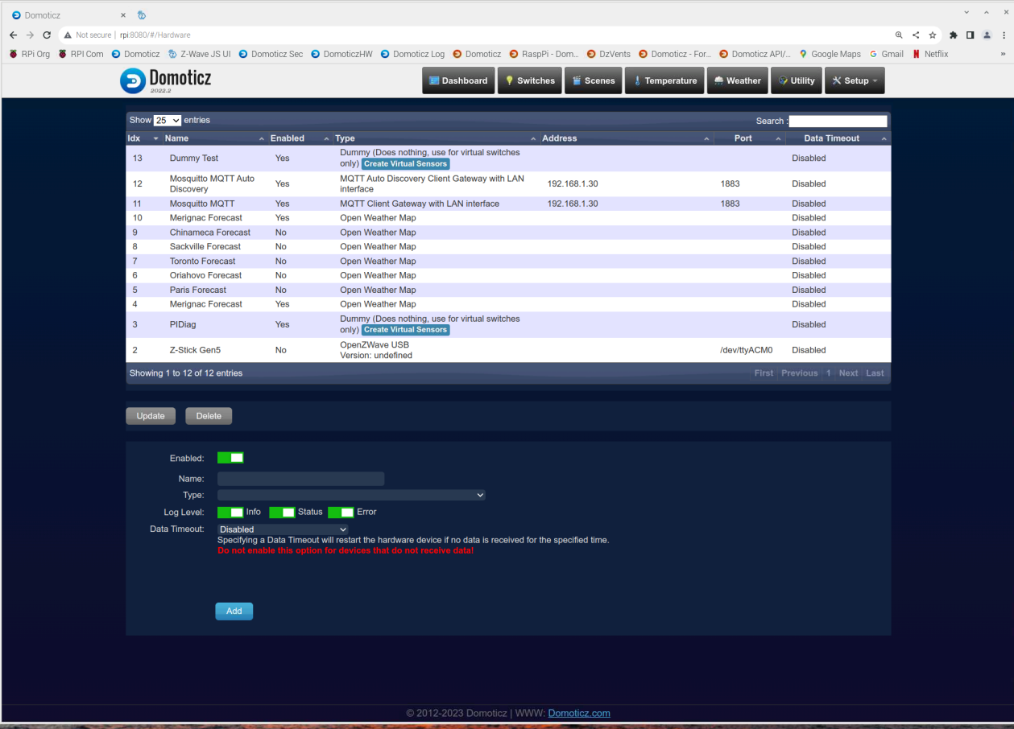

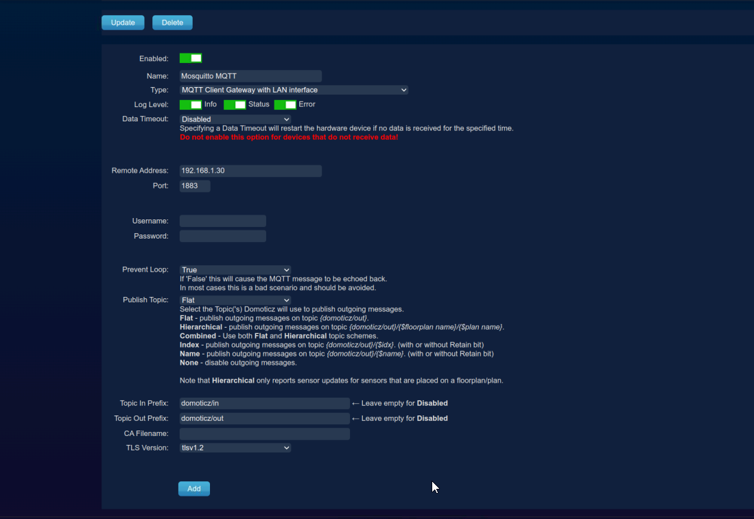

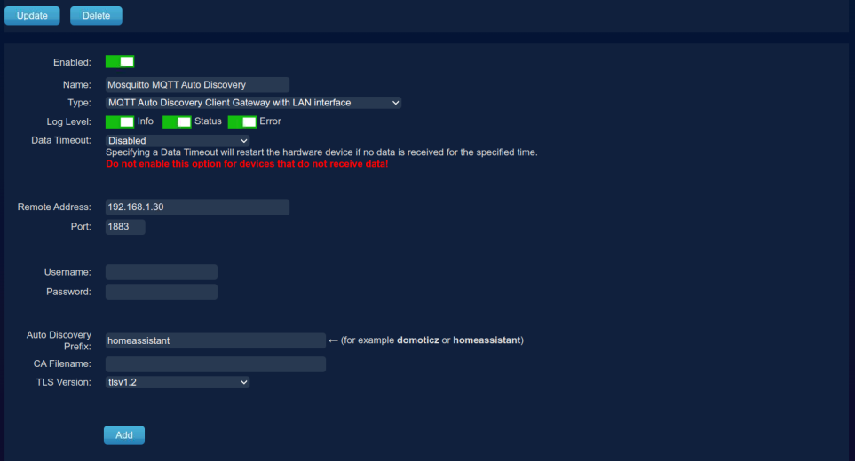

## New Devices from Zwave-JS-UI

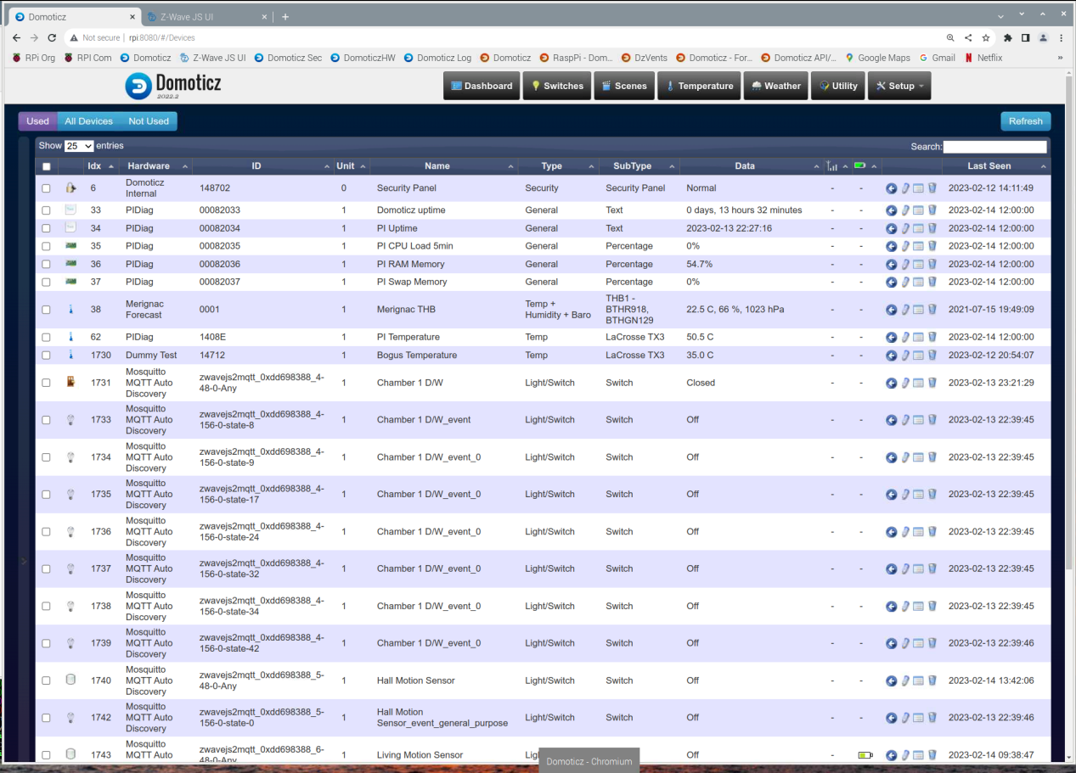

## Zwave-JS-UI Control Panel Page 1

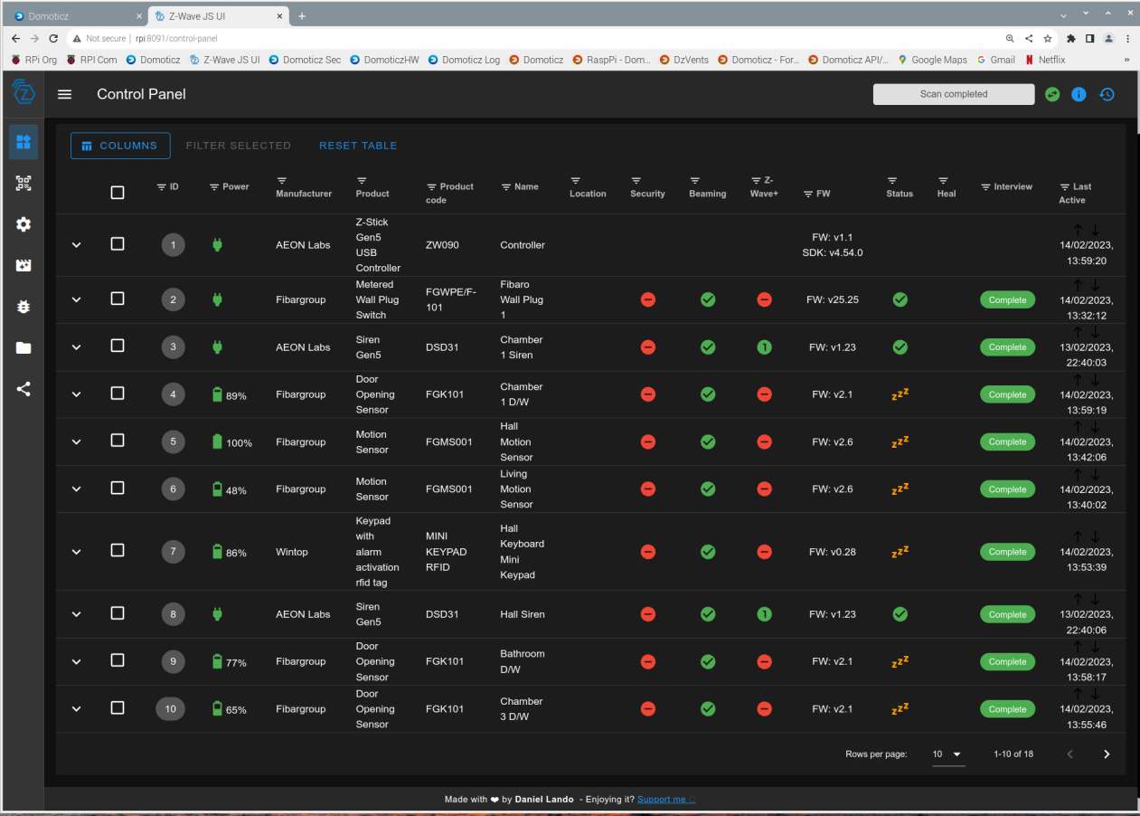

## Zwave-JS-UI Control Panel Page 2

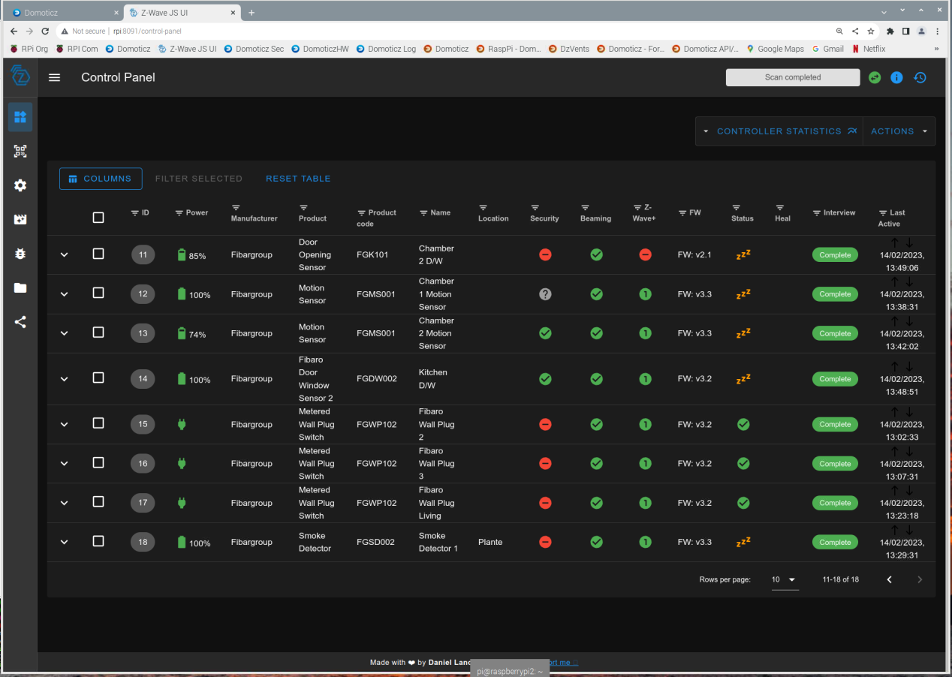

## Zwave-JS-UI Provisioning Entities

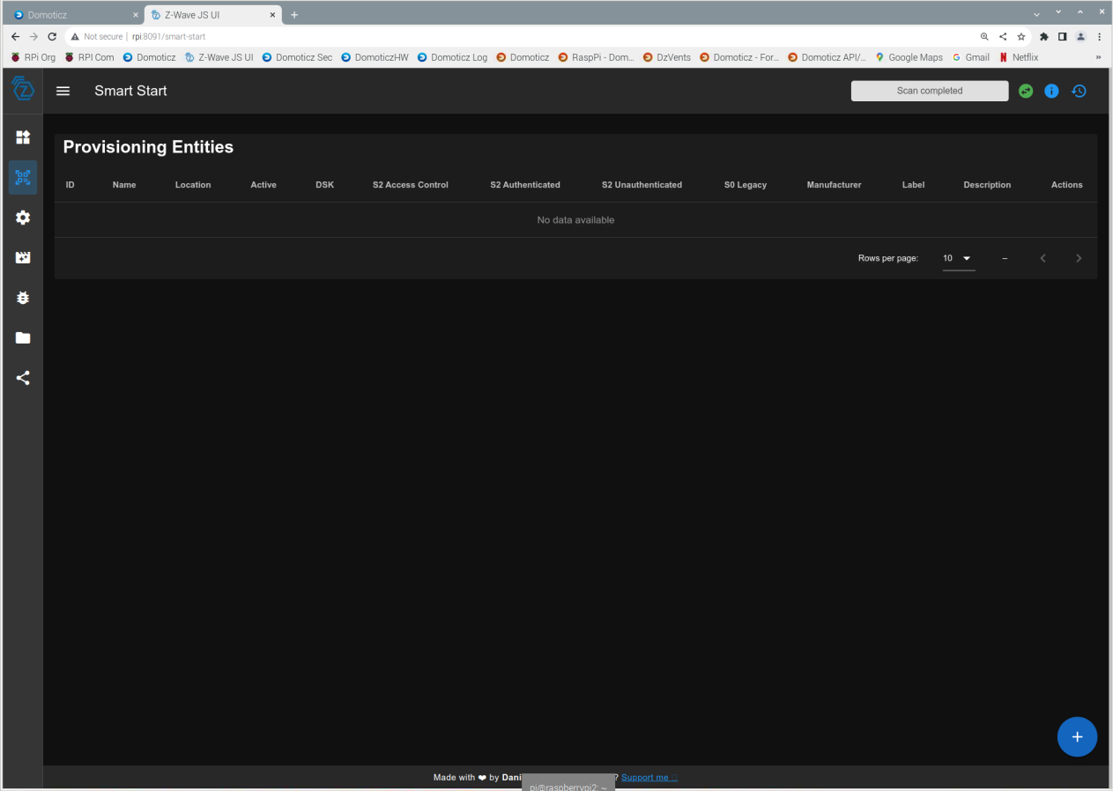

## Zwave-JS-UI Settings

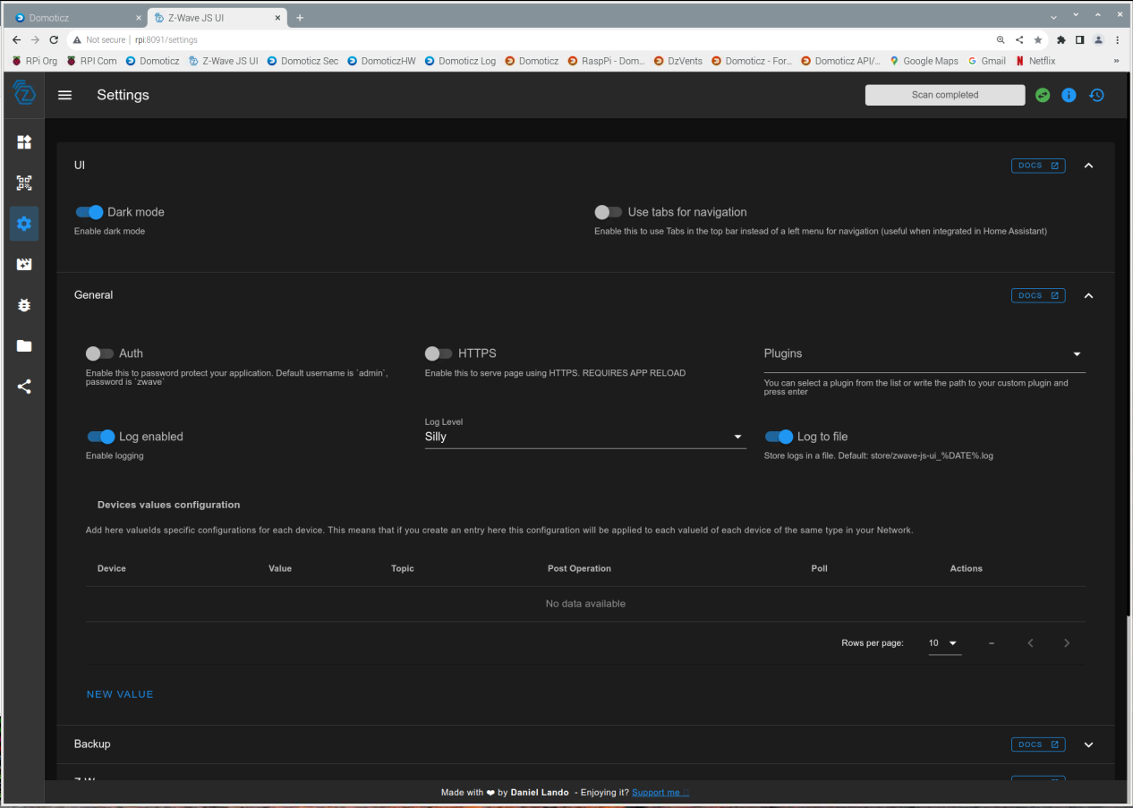

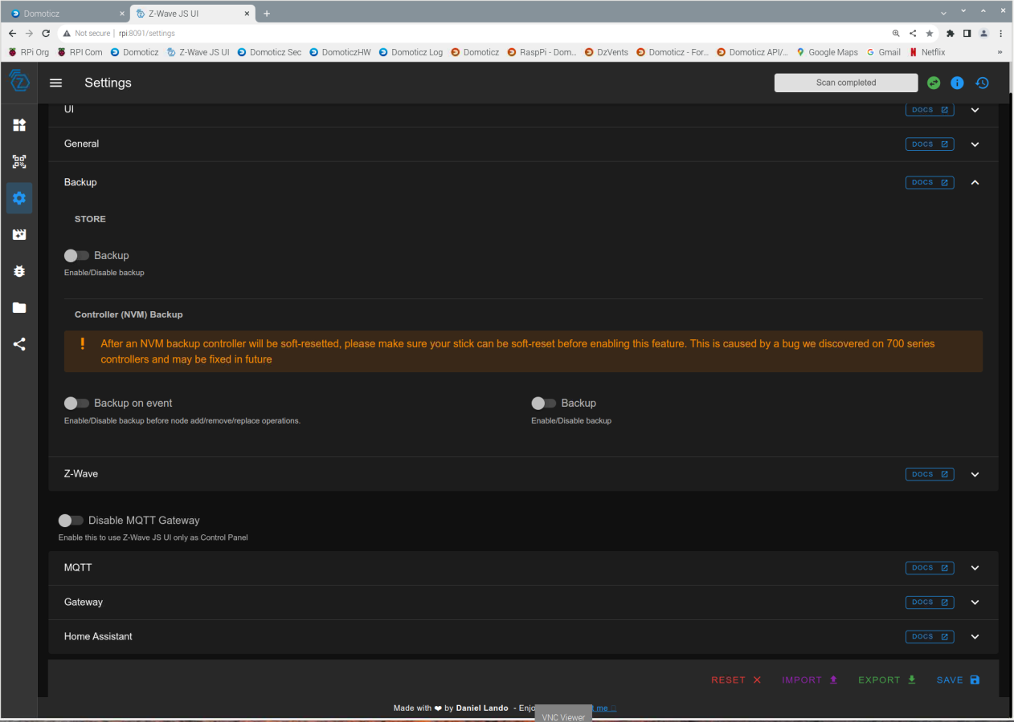

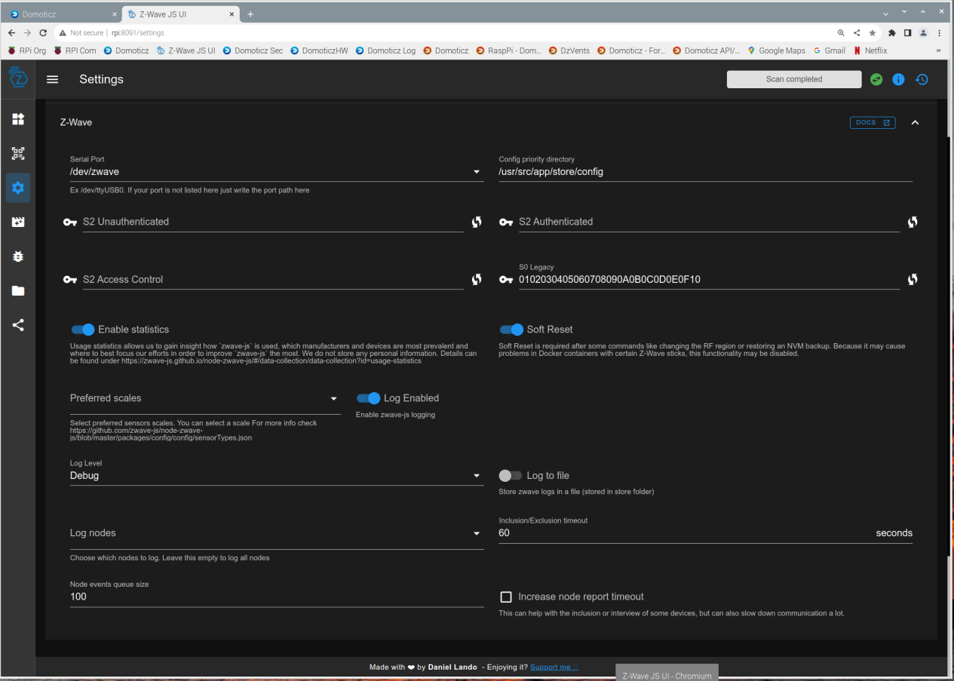



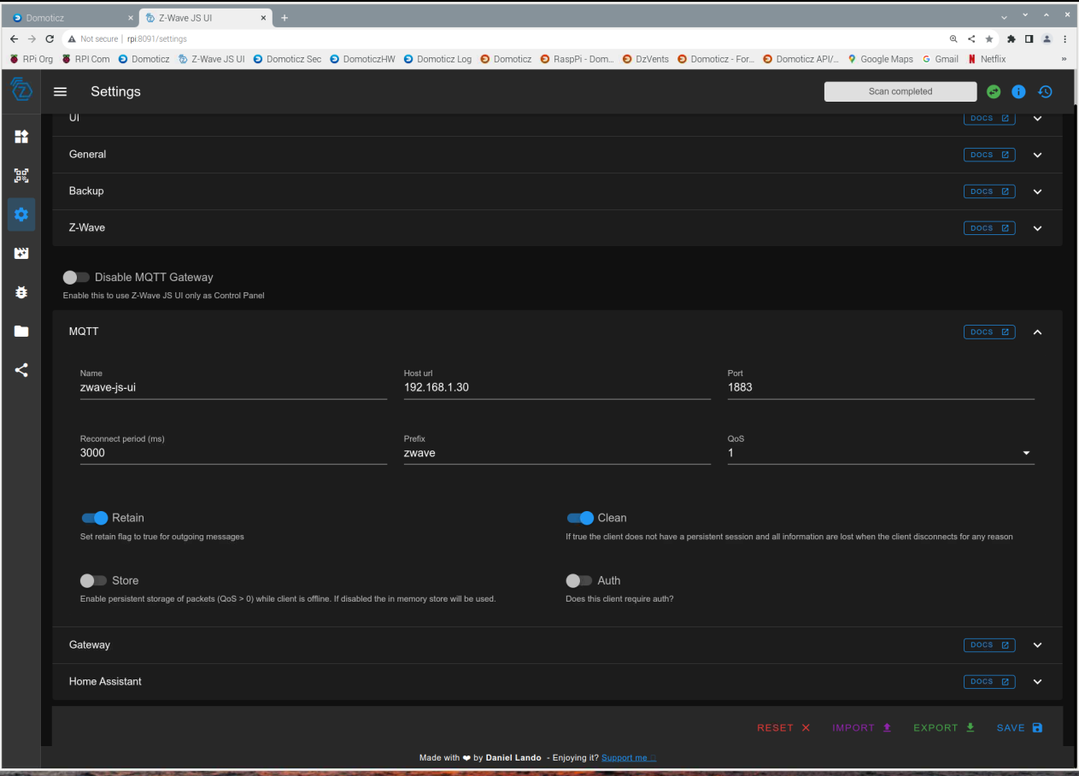

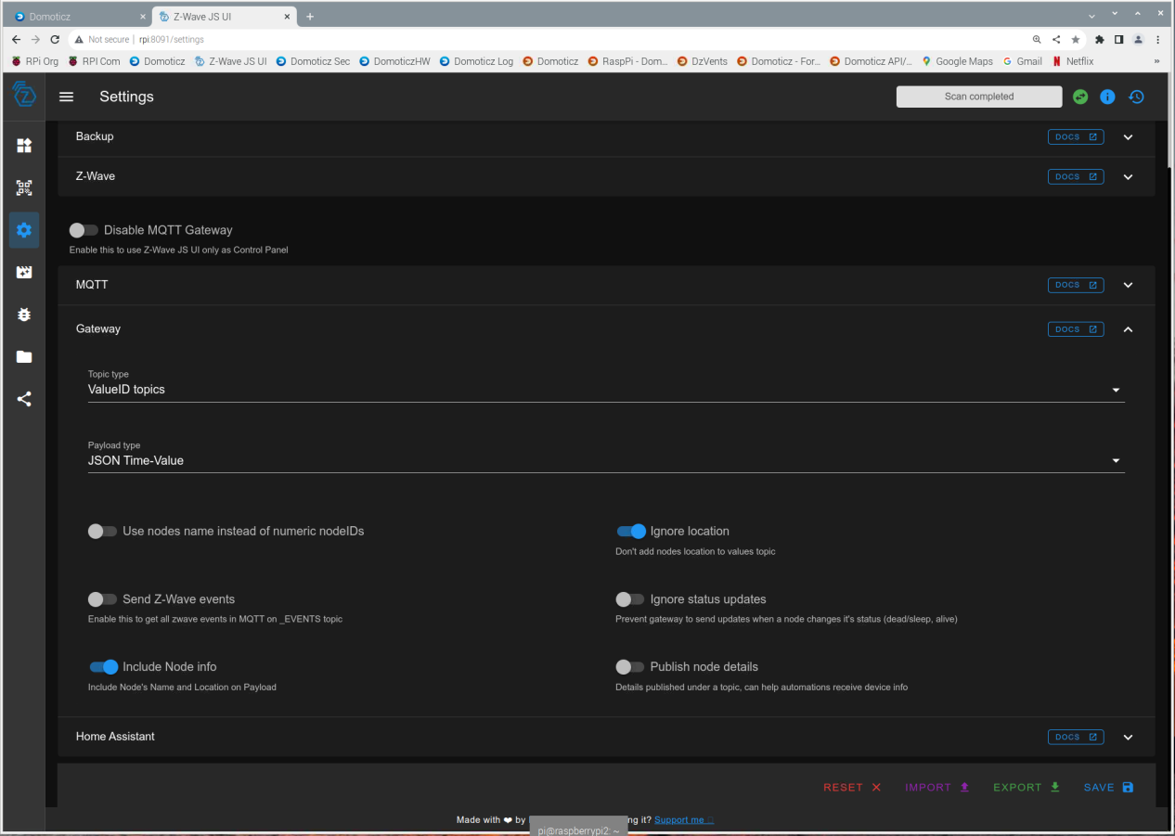

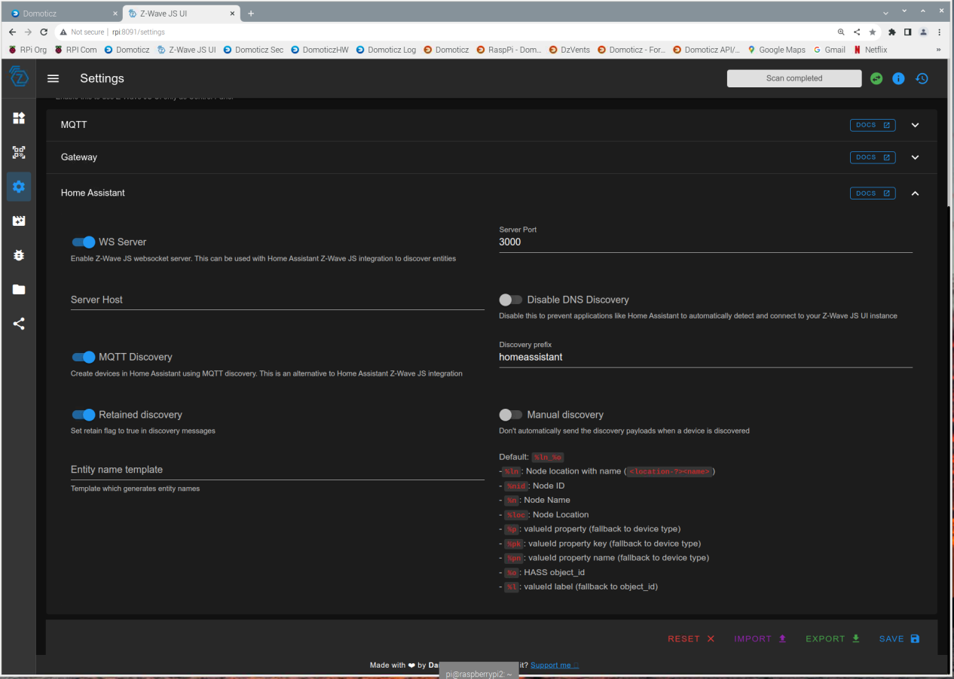

## Zwave-JS-UI Debug

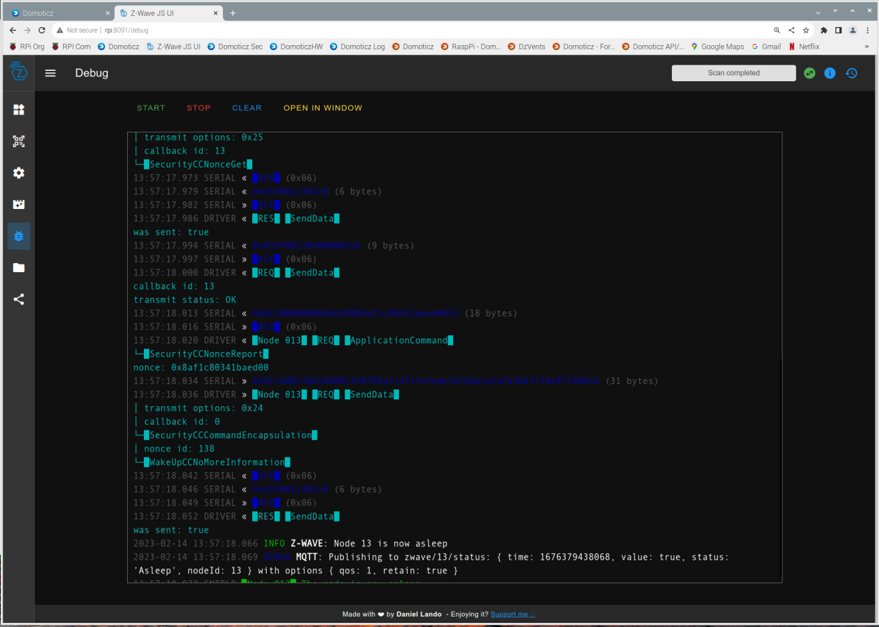

## Zwave-JS-UI Store

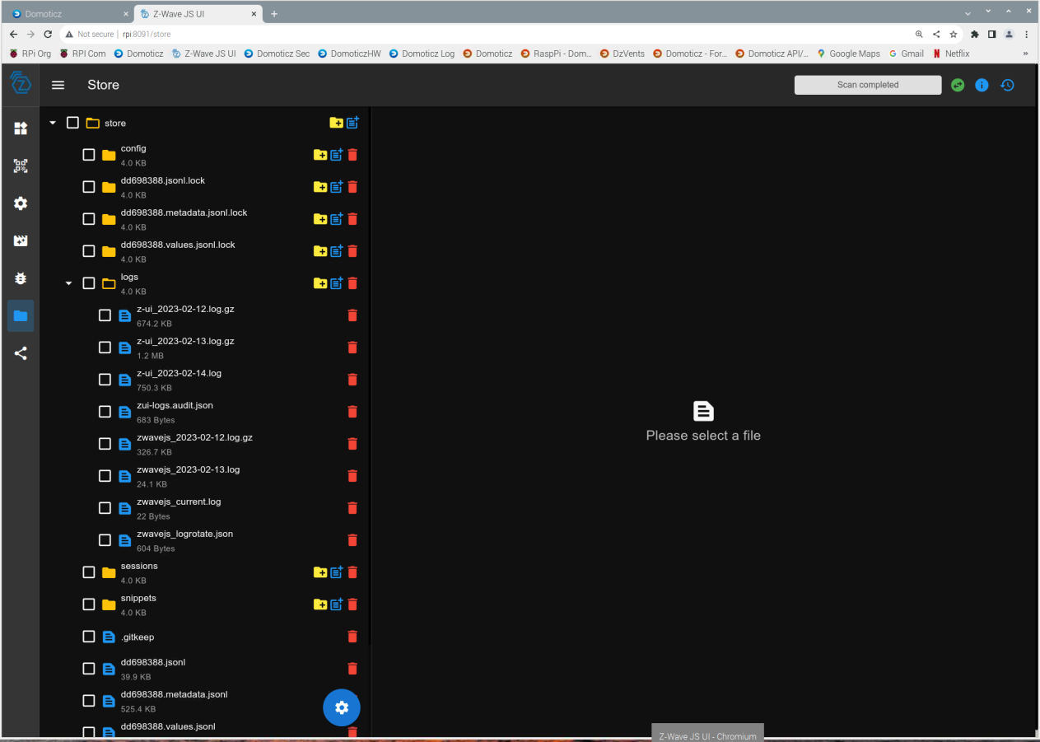

## Zwave-JS-UI Network

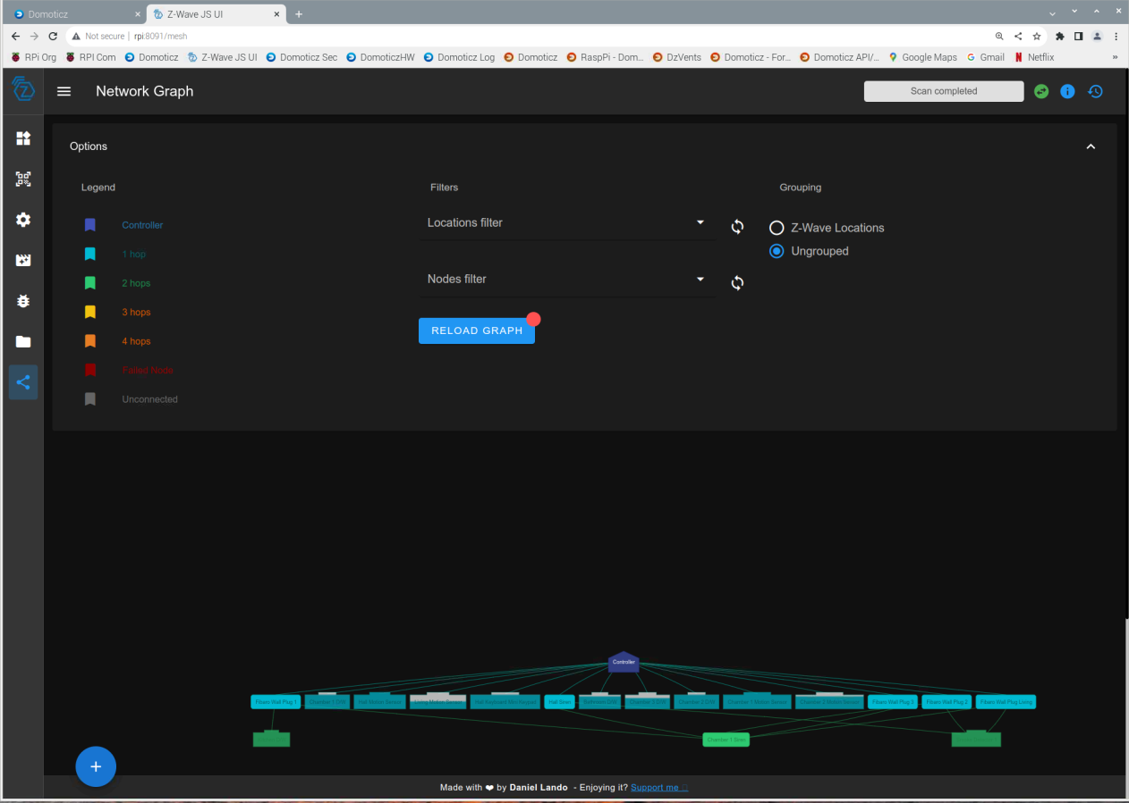

## Zwave-JS-UI Debug Errors with localhost IP

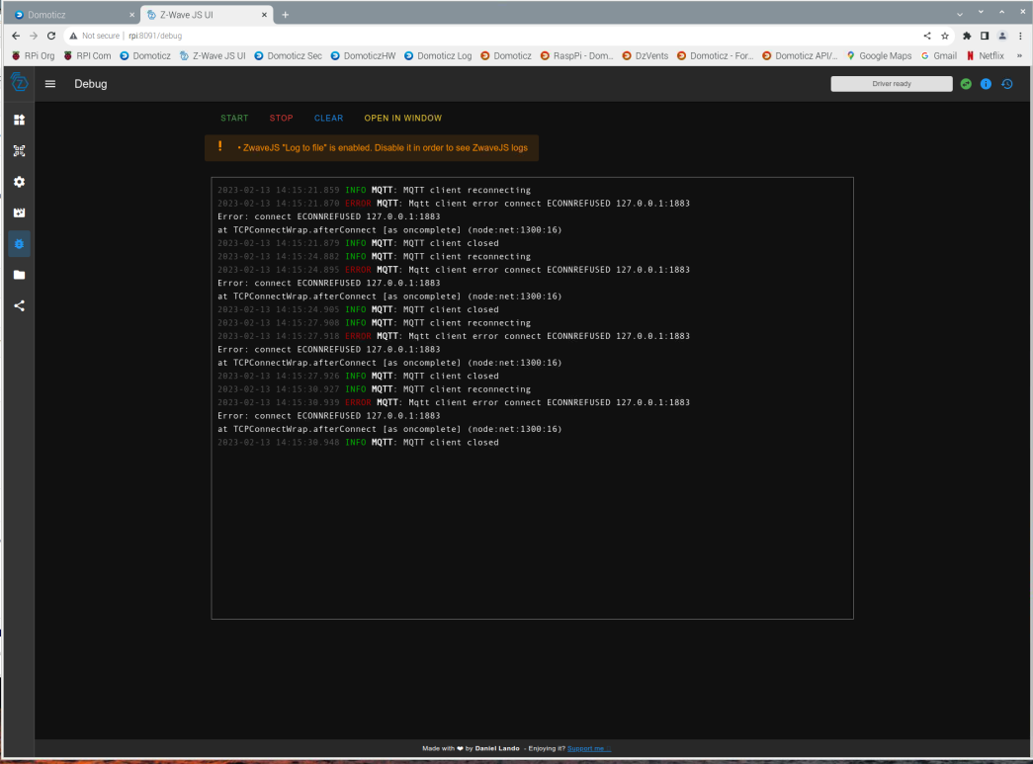

# Remote Access

## VNC

RPI distribution usually comes with RealVNC Server which must be enabled and RealVNC Viewer which needs to be installed. Link to main website <https://www.realvnc.com/en>

Freeware version allows up to five hosts to be accessible in your LAN. Sandbox host is normally runnning at least one terminal and browser which quickly allow user to access Domoticz host machine. This should be enough for most personal situation.

## DuckDNS

If you need to create your own domain, Home Assistant recommends to use DNSDucks. Here is my personal experience.

Create DuckDNS domain for free. Go to address below and sign in with say your gmail account. Give user name and your choice of domain. In a matter of a few minutes it done and the website will give details about your account which you should note them down.

<https://www.duckdns.org/> access via google account

Duck DNS Account example

someone.somewhere@gmail.com

type free

token 32 char user

token generated 27 seconds ago

created date 26 Mar 2023, 10:47:18

subdomain someone.duckdns.org

HTTP API Specification

The update URL can be requested on HTTPS or HTTP. It is recommended that you always use HTTPS

We provide HTTP services for unfortunate users that have HTTPS blocked

You can update your domain(s) with a single HTTPS get to DuckDNS

https://www.duckdns.org/update?domains={YOURVALUE}&token={YOURVALUE}[&ip={YOURVALUE}][&ipv6={YOURVALUE}][&verbose=true][&clear=true]

It likely that your router IP address is dynamic; thus, DuckDNS must know about new IPs to ensure that routing is properly done. Literature suggest to use an application called inadyn which is maintained but not for Debian distribution. The standard files installed by RPI are inadyn ver 1.99 and I did not find a way to configure it for DuckDNS. After some research, I found site http://troglobit.com/inadyn.html

Downloaded from Github a tar of inadyn-2.10.0 and extracted in */home/pi/store/inadyn*. Copied to */home/pi/store/inadyn/inadyn-2.10.0* Dockerfile, autogen.sh, configure.ac, indent.sh from Github Troglobit page

Build Container

$ sudo docker build -t inadyn:latest .

Container build works without any errors.

Load Container

Copied /etc/inadyn.conf to /home/pi/store/inadyn/inadyn-2.10.0

# In-A-Dyn v2.0 configuration file format

period = 300

user-agent = Mozilla/5.0

# The FreeDNS username must be in lower case

# The password (max 16 chars) is case sensitive

provider duckdns.org {

username = 271f2b3d-627b-44f4-af88-4c8cfa46095d

password = noPasswordForDuckdns

hostname = someone.duckdns.org

}

Run the following command.

$ sudo docker run --rm -v "$PWD/inadyn.conf:/etc/inadyn.conf" inadyn:latest

In-a-dyn version 2.10.0 -- Dynamic DNS update client is running. Will need to create another **docker-compose.yml**  to load inadyn on start-up for now it’s done via a script.

# NAT Router set-up

You will need to allow port forwarding in your router so that the certificate authority can verify host machine. Port forwarding will depend upon your particular router.

Please keep in mind that you are now leaving your system directly connected to the internet. You will need to close/open ports as needed.

Application/Service Port interne Port externe Protocole Équipement IP externe

Web Server (HTTP) 80 80 TCP raspberrypi2 Toutes supprimer

Secure Web Srv (HTTPS) 443 443 TCP raspberrypi2 Toutes supprimer

# Certificate with snapd & certbot

Please go to wiki page blow for more details concerning the certificate and how to transfer it to Domoticz.

<https://www.domoticz.com/wiki/Native_secure_access_with_Lets_Encrypt>

Installed snap 2.49 with Add/Remove Software to get a certificate used from let’s encrypt.

$ sudo snap install core; sudo snap refresh core

$ sudo snap install --classic certbot

$ sudo ln -s /snap/bin/certbot /usr/bin/certbot

$ sudo certbot certonly --standalone

Saving debug log to /var/log/lets encrypt/letsencrypt.log

Please enter the domain name(s) you would like on your certificate (comma and/or

space separated) (Enter 'c' to cancel): someone.duckdns.org

Requesting a certificate for someone.duckdns.org

Successfully received certificate.

Certificate is saved at: /etc/letsencrypt/live/someone.duckdns.org/fullchain.pem

Key is saved at: /etc/letsencrypt/live/someone.duckdns.org/privkey.pem

This certificate expires on 2023-07-01.

These files will be updated when the certificate renews.

Certbot has set up a scheduled task to automatically renew this certificate in the background.

- - - - - - - - - - - - - - - - - - - - - - - - - - - - - - - - - - - - - - - -

# Scripts

Shell scripts are like macros in EXCEL. These can make repetitive or complex syntax command very simple. Scripts can take arguments and even be interactive to allow with great flexibility.

For these reasons above, I strongly recommend to to invest time in creating system scripts to make life easier as "system administrator". Combining OS and DzVents scripts will enhance your Domoticz experience. I attach examples of personal scripts used to survey and maintain OS.

## mdown.sh

#!/bin/bash

echo "First stop Monit"

#

sudo /etc/init.d/monit stop

#

echo "Then stop Domoticz"

#

sudo /etc/init.d/domoticz.sh stop

#

echo "When you are done modifying/updating/whatever, start Domoticz first:"

#

echo "Start Domoticz"

echo "sudo /etc/init.d/domoticz.sh start"

#

echo "Then start Monit again"

#

echo "sudo /etc/init.d/monit start"

#

## updom.sh

#!/bin/bash

# Ensure that Domotics is up and running

#

sudo service domoticz.sh stop

sudo service domoticz.sh start

sudo service domoticz.sh status

#

echo "Then start Monit again"

sudo /etc/init.d/monit start

## rpidia.sh

#!/bin/bash

#Read RPI uptime and temperature

#Use top for general overview of CPU LOAD % RAM usage

#Use head command is extracts the first 5 lines

#Must set decimal separator to decimal so that mawk works properly

#MAWK CVS format output: rpiuptime, rpicpu(5min), rpiRAM, rpiSWAP, rpitemp

rpiup=$(uptime -s)

temp=$(vcgencmd measure\_temp | egrep -o '[0-9]\*\.[0-9]\*')

ssize=$(egrep CONF\_SWAPSIZE /etc/dphys-swapfile | egrep -o '[0-9]\*')

#Get Swapsize in the event that swapoff -a is set

LC\_ALL="C" top -b -n 1 | head -n 5 | mawk -v rpiup="$rpiup" -v temp="$temp" -v ssize=$ssize '

BEGIN{ {printf ("%19s",rpiup)}

{printf("%c",",")}

}

/load average/ {printf ("%3.1f", substr($13,1,length($13)-1)\*100)}

/load average/ {printf("%c",",")}

/MiB Mem/ {printf ("%3.1f",$8/$4\*100)}

/MiB Mem/{printf("%c",",")}

/MiB Swap/{printf("%3.1f",$7/ssize\*100)}

/MiB Swap/{printf("%c",",")} END{{printf("%3.1f\n",temp)}}

'

## inadyn.sh

#!/usr/bin/env bash

cd /home/pi/store/inadyn/inadyn-2.10.0

sudo docker run --rm -v "$PWD/inadyn.conf:/etc/inadyn.conf" inadyn:latest

#

## smeagol.sh

#!/usr/bin/env bash

cd /home/pi/store

sudo docker pull smeagolworms4/mqtt-explorer

sudo docker run -p 4000:4000 -v$(pwd)/config:/mqtt-explorer/config smeagolworms4/mqtt-explorer

#

# Glossary

Bash : Bourne again shell

CLI : Command Line Input given in a Linux terminal environment

Host : PC/RPI which runs a specific application such as Domoticz

LAN : Local Area Network such as at home 192.168.0.1

RPI : Raspberry Pi

UPS : Uninterruptible Power Supply

GUI : Graphical User Interface

VPN : Virtual Private Network

VNC : Virtual Network Computing

WAN : Wide Area Network such as Internet